BANGLADESH WATER DEVELOPMENT BOARD

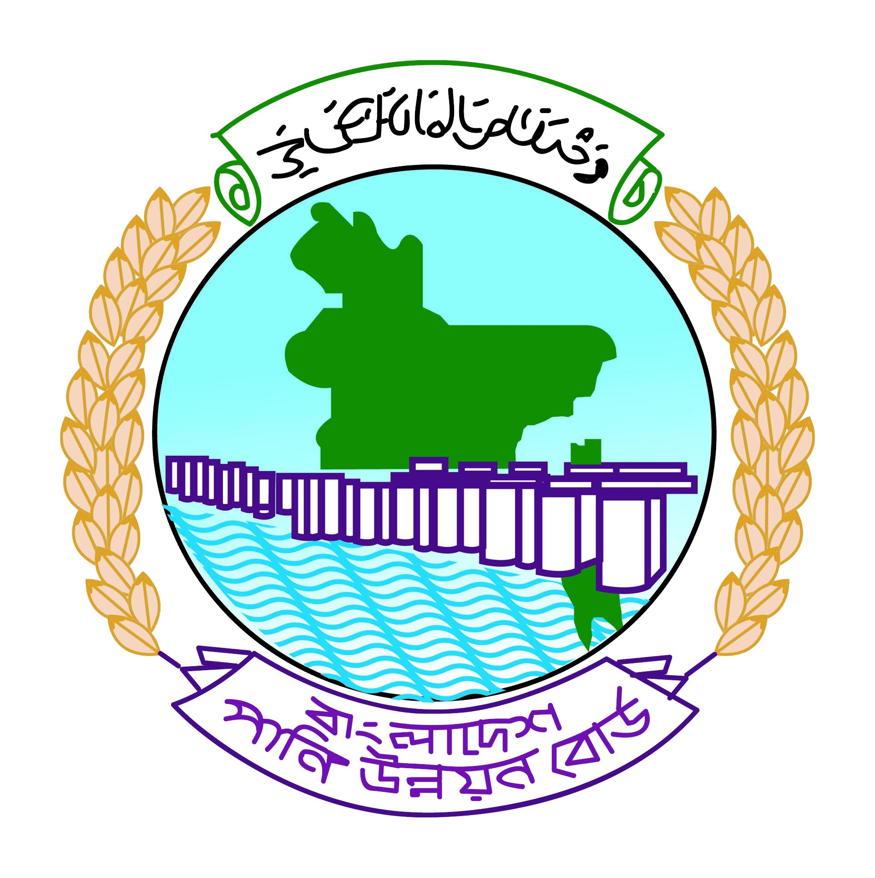

DESIGN DATA
FOR

Protective work along the Right Bank of Pasur River from km. 0.000 to km 0.600 = 600m Near Wildlife Breeding Center in Koromjol,Upazilla Mongla, District: Bagerhat Under Bagerhat O&M Division, BWDB, Bagerhat.

BAGERHAT O&M DIVISION,BWDB, BAGERHAT.

Khulna O&M Circle, BWDB, Khulna.

South-Western Zone, BWDB, Khulna.

